

ADAPTIVE LOCATION BASED REMINDER USING SPEED AWARE GEOFENCING
A Project Report

Submitted by

HARINEE V S (61781922102040) ANNAPOORANI D (61781922102009)
ASMATH HAZEENA M (61781922102014)
DHARSHINI R (61781922102022)

In partial fulfillment for the award of the degree

Of
BACHELOR OF ENGINEERING

IN
COMPUTER SCIENCE AND ENGINEERING

SONA COLLEGE OF TECHNOLOGY (AUTONOMOUS), SALEM– 636005
ANNA UNIVERSITY: CHENNAI 600 025
APRIL 2026

ADAPTIVE LOCATION BASED REMINDER USING SPEED AWARE GEOFENCING
A Project Report

Submitted by

HARINEE V S (61781922102040) ANNAPOORANI D (61781922102009)
ASMATH HAZEENA M (61781922102014)
DHARSHINI R (61781922102022)

In partial fulfillment for the award of the degree

Of
BACHELOR OF ENGINEERING

IN
COMPUTER SCIENCE AND ENGINEERING

SONA COLLEGE OF TECHNOLOGY (AUTONOMOUS), SALEM– 636005
ANNA UNIVERSITY: CHENNAI 600 025
APRIL 2026
SONA COLLEGE OF TECHNOLOGY (AUTONOMOUS) ANNA UNIVERSITY: CHENNAI 600 025

BONAFIDE CERTIFICATE

Certified that this project report “ADAPTIVE LOCATION BASED
REMINDER SYSTEM USING SPEED AWARE GEOFENCING” is the
Bonafide work of “ HARINEE V S (61781922102040), ANNAPOORANI D
(61781922102009), ASMATH HAZEENA M (61781922102014),
DHARSHINI R (61781922102022)” who carried out the project work under my supervision.

SIGNATURE SIGNATURE
Dr. B. Sathiyabhama G. Sudha
Professor Assistant Professor
Head of the Department SUPERVISOR
Department of Computer Science Department of Computer Science and Engineering and Engineering
Sona College of Technology, Sona College of Technology,
Salem – 636005. Salem – 636005.

Submitted for the project viva-voce examination held on ………...

INTERNAL EXAMINER EXTERNAL EXAMINER

SONA COLLEGE OF TECHNOLOGY (AUTONOMOUS), SALEM DEPARTMENT OF COMPUTER SCIENCE ENGINEERING U19CSE801 – PROJECT WORK – DECLARATION FORM

Declaration by the Students

We hereby declare that the project titled “ADAPTIVE LOCATION BASED REMINDER SYSTEM USING SPEED AWARE GEOFENCING” is an original work carried out by us under the guidance of “Ms. Sudha G”. This project has not been submitted elsewhere for the award of any degree.

We also affirm that all the data and information used in this project are genuine and properly acknowledged. This project work is carried out with reference to the United Nations Sustainable Development Goal SDG 11 - Sustainable Cities and Communities.

Student Detail
S.NO | REGISTER NUMBER | NAME | SIGNATURE
1. | 61781922102040 | HARINEE V S
2. | 61781922102009 | ANNAPOORANI D
3. | 61781922102014 | ASMATH HAZEENA M
4. | 61781922102022 | DHARSHINI R

Date: ______________
Place: Sona College of Technology

ACKNOWLEDGMENT

First and foremost, I would like to express my gratefulness to our honourable
Chairman Sri. C Valliappa our Vice Chairman Sri. Chocka Valliappa and Sri Thyagu Valliappa and the management of Sona College of Technology for bringing me constant encouragement throughout this course.
My sincere thanks go to Dr. S. R. R. Senthil Kumar, Principal, Sona College of Technology, who has motivated me in my entire endeavours. I wholeheartedly thank Dr. B. Sathiyabhama, Professor and Head of the Department of Computer Science and Engineering, Sona College of Technology, Salem for giving constant encouragement and rendering all kinds of support throughout the course.
I take this opportunity to express our deepest gratitude and special thanks to our project guide and class counsellor, Ms. G. Sudha, Assistant Professor, Department of Computer Science and Engineering, Sona College of Technology, for her valuable guidance, continuous support, and encouragement throughout the project.
I would like to thank my parents and all my friends from the bottom of my heart, who were always present to help me out and make this project a success. Last but not least, I would like to express my heartiest thanks and gratefulness to almighty God for his divine blessings, which helped me complete the final year project successfully. This project was made possible because of inestimable inputs from everyone involved, directly or indirectly.

ABSTRACT
In the modern digital era, cryptocurrency blockchain forensics has become critical for law enforcement agencies investigating illicit narcotics syndicates, financial crimes, and money laundering. However, most existing commercial forensics platforms operate as proprietary, closed black-box cloud systems that require exfiltrating sensitive investigative queries to third-party servers, lack transparent mathematical proofs, and struggle with sophisticated obfuscation techniques such as peel chains, CoinJoin mixers, and cross-chain asset hops. This creates critical operational security risks and severe admissibility hurdles under strict judicial evidence standards. To address these challenges, the proposed AegisTrace workstation provides an end-to-end, mathematically verifiable, client-side cryptocurrency forensics platform. Operating within a zero-trust browser environment via dual-gateway live mainnet integration, it executes an 8-Factor Heuristic Classifier to disambiguate change outputs from true payment flows, achieving around 95% accuracy across labeled ground-truth mainnet topologies with an honest 91.7% coverage rate. The system is designed for computational efficiency and rigorous fund tracking by employing a multi-model taint engine supporting Proportionate (Haircut), FIFO, and Poison contamination dynamics alongside strict value-conservation invariants. For network-level de-anonymization, it uses Disjoint Set Union (DSU) clustering with path compression running in near-linear time and Shannon entropy scoring to detect mixer participation, while disassembling cross-chain bridge memos to follow flight paths across secondary blockchains. To guarantee judicial validity, the system integrates a cryptographic SHA-256 hash-chained chain-of-custody ledger, automatically generating statutory Section 67 NDPS Act freeze notices and tamper-evident Section 65B Indian Evidence Act / Section 63 BSA 2023 compliance certificates. Overall, the proposed system provides a more transparent, privacy-preserving, and court-admissible solution than traditional proprietary platforms, delivering verifiable blockchain intelligence and superior investigative outcomes.

TABLE OF CONTENTS

Chapter Title Page no. no.
ACKNOWLEDGEMENT iv ABSTRACT v LIST OF FIGURES ix LIST OF ABBREVIATIONS x
1 INTRODUCTION 1

1.1 OVERVIEW 1 1.2 PROBLEM STATEMENT AND MOTIVATION 2 1.3 OBJECTIVE 3
1.3.1 TECHNICAL IMPLEMENTATION OBJECTIVES 4

1.4 SCOPE OF PROJECT 6
1.4.1 SCOPE BOUNDARIES AND EXCLUSIONS 6
2 LITERATURE SURVEY 8

2.1 LOCATION-BASED AMBULANCE BOOKING AND TRACKING 8
SYSTEM

2.2 RELARMY: LOCATION-BASED REMINDER SYSTEM 8 2.3 MOBIMINDER: ANDROID-BASED LOCATION 9
REMINDER APPLICATION
2.4 INTELLITASK: AI-ENHANCED REMINDER SYSTEM 9 2.5 HOLA: LOCATION-BASED REMINDER APPLICATION 9 2.6 DEEP LEARNING-BASED LANGUAGE MODELS FOR NLU 10 2.7 COMPARATIVE ANALYSIS OF EXISTING SYSTEMS 10 2.8 RESEARCH GAP AND CONTRIBUTION ¹²
3 SYSTEM ANALYSIS 14

3.1 EXISTING SYSTEM 14 3.2 PROPOSED SYSTEM 14 3.3 PROPOSED SYSTEM ARCHITECTURE 15 3.4 SYSTEM SPECIFICATION 18
3.4.1 SOFTWARE REQUIREMENTS 18
4 SYSTEM DESIGN 19

4.1 MODULE LIST 19 4.2 DYNAMIC ADAPTIVE REMINDER TRIGGERING MECHANISM 19
4.2.1 MOTION-AWARE BATTERY EFFICIENCY 19
CONTROLLER
4.2.2 SPEED-BASED GEOFENCE RADIUS 19
4.2.3 DISTANCE COMPUTATION AND GEOFENCE ENTRY 20
DETERMINATION
4.2.4 TOP-K SELECTION STRATEGY 21
4.2.5 GAP OPTIMIZATION 21
4.2.6 NEAREST GEOFENCE SELECTION FROM TOP-K 21
4.2.7 ADAPTIVE GPS POLLING INTERVAL 22
4.2.8 MAIN LOCATION UPDATE CONTROLLER 22
4.2.9 GEOFENCE TRIGGER WATCHER 22
4.3 INTELLIGENT REMINDER CREATION 23
4.3.1 USER AUTHENTICATION 23
4.3.2 VOICE / MANUAL INPUT ACQUISITION 23
4.3.3 NLP PROCESSING 23
4.3.4 HYBRID INTENT DETECTION 23
4.3.5 TSIE AND CASA-BASED HYBRID SLOT EXTRACTION 23
4.3.6 CONFIDENCE CALCULATION 24
4.3.7 DATABASE STORAGE 24
- RESULTS AND DISCUSSION 25
  - SYSTEM OVERVIEW AND EXPERIMENTAL SETUP 25
  - DYNAMIC GEOFENCING PERFORMANCE ANALYSIS 25
  - COMPARISON WITH STATIC GEOFENCING 25
  - BATTERY EFFICIENCY EVALUATION 25
  - SYSTEM ACCURACY AND PERFORMANCE METRICS 26
  - SCALABILITY AND REAL-TIME PERFORMANCE 26
  - ROBUSTNESS TO REAL-WORLD USER INPUT 26
  - PRACTICAL USABILITY IN URBAN ENVIRONMENTS 27
  - COMPARISON WITH EXISTING SYSTEMS 27
  - LIMITATIONS AND FUTURE IMPROVEMENTS 27

- CONCLUSION AND FUTURE WORK 28
- APPENDIX 29

A1 CODE 29 A2 SYSTEM SCREENSHOTS 32
- SDG GOALS 42
- REFERENCES 43
- PUBLICATION 45
- GRAMMARLY PLAGIARISM 49
LIST OF FIGURES
S. No Title Page No.
3.3 CHAPTER 3 14
    - System Architecture 15
    - Class Diagram 15
    - Use Case Diagram 16
    - Activity Diagram 17
A2 APPENDIX 29
A2.1 Create Account 36
A2.2 Sign in 37
A2.3 Dashboard 37
A2.4 Create reminders 37
A2.5 Location 37
A2.6 Voice Reminder 38
A2.7 Friends 38
A2.8 Notifications 38
A2.9 Reminders 38
A2.10 Database Users 39
A2.11 Database Reminders 39

LIST OF ABBREVIATIONS AND NOMENCLATURE
Abbreviation | Description
GPS | Global Positioning System
NLP | Natural Language Processing
TSIE | Tri-Slot Intent Extraction
CASA | Correction-Aware Slot Adaptation
API | Application Programming Interface
UI | User Interface
JSON | JavaScript Object Notation
R(v) | Dynamic Geofence Radius Function
Top-K | Top K Nearest Elements
STT | Speech-to-Text
NER | Named Entity Recognition
GPE | Geo-Political Entity
LOC | Location Entity
ORG | Organization Entity
FAC | Facility Entity

CHAPTER 1
INTRODUCTION
1.1 OVERVIEW
The rapid adoption of decentralized digital assets and pseudonymous cryptocurrencies has fundamentally transformed global financial ecosystems while introducing unprecedented challenges for law enforcement agencies. Modern criminal syndicates, darknet narcotics vendors, and illicit financing networks increasingly exploit the pseudo-anonymous architecture of the Bitcoin blockchain to launder proceeds of crime across international borders. For instance, when investigative agencies like the Narcotics Control Bureau (NCB) or specialized cybercrime units intercept an illicit transaction hash or target wallet address, they must systematically de-anonymize the underlying money flows—unraveling complex layering schemes such as rapid peel chains, smurfing consolidations, and CoinJoin anonymizing pools. In the proposed system, AegisTrace, an end-to-end client-side cryptocurrency forensics workstation is implemented, enabling investigators to trace live Bitcoin mainnet transactions, reconstruct transaction graphs, classify change versus payment outputs, measure taint propagation, and compile tamper-evident court exhibits.
Unlike conventional commercial forensic suites that operate as closed, proprietary black-box cloud platforms requiring investigators to upload confidential investigative targets to remote commercial servers, AegisTrace is engineered on a pure client-side, zero-trust architecture. It interfaces directly with live decentralized ledger gateways (Blockstream Esplora and Mempool.space) utilizing an automated circuit-breaker failover mechanism and localized Least Recently Used (LRU) caching. To eliminate heuristic guesswork in transaction decomposition, the system introduces an 8-Factor Heuristic Change-vs-Payment Classifier. This algorithmic model evaluates script-type consistency, address reuse, value roundness, peel share ratios, output positioning, dwell timing, and mempool fee markets to compute a mathematically bounded confidence metric:
$$\text{Confidence}=\max\left(0 , \min\left(1 , \frac{∣\text{Score}∣-θ}{{\text{Margin}}_{max}}\right)\right)×γ^{\text{depth}}$$
where θ represents the decision boundary threshold and γ denotes the per-hop depth decay factor (γ = 0.92). Furthermore, AegisTrace incorporates a Triple Taint Propagation Engine supporting three mathematically distinct legal models: Proportionate (Haircut), First-In First-Out (FIFO), and Poison (100% Contamination) with continuous value-conservation invariants (Σ T_in = Σ T_out + Fee_taint). For entity de-anonymization, the system utilizes a Disjoint Set Union (DSU) algorithm with path compression achieving near-linear time complexity for Common Input Ownership Heuristic (CIOH) clustering, alongside Shannon entropy calculation (H(X) = -Σ p_i log2 p_i) to detect equal-denomination Wasabi and Whirlpool CoinJoin mixing pools. Cross-chain bridge memo disassemblers extract secondary destination addresses across Ethereum, Tron, and Solana networks. Empirical validation demonstrates that AegisTrace achieves around 95% classification accuracy across ground-truth mainnet transaction topologies with an honest 91.7% coverage rate, sub-50 ms client-side calculation latency, and complete verification across a rigorous automated suite of 33 test suites and 221 unit tests.
Overall, the proposed system provides a scalable, cryptographically verifiable, and sovereign intelligence workstation for blockchain forensics. By addressing the severe limitations of existing commercial cloud platforms, AegisTrace ensures complete operational privacy for investigating officers, maintains unbroken digital chains of custody, and automates the production of statutory legal notices under Section 67 of the NDPS Act, 1985, as well as electronic evidence certificates compliant with Section 65B of the Indian Evidence Act, 1872 (and Section 63 of the Bharatiya Sakshya Adhiniyam, 2023). The modular architecture ensures seamless extensibility for emerging blockchain networks, automated smart contract decompilation, and machine-learning-driven syndicate profiling.
1.2 PROBLEM STATEMENT AND MOTIVATION
The exponential growth of decentralized cryptocurrencies has illuminated severe operational and technical limitations in current forensic methodologies used by law enforcement agencies. Traditional financial investigations rely on centralized banking intermediaries governed by mandatory Know Your Customer (KYC) regulations and subpoena-backed transaction ledgers. In contrast, public blockchain networks operate without centralized gatekeepers, relying on cryptographic public-key infrastructure where entities can generate virtually unlimited pseudonymous addresses for every inbound and outbound transfer.
Existing cryptocurrency forensic methodologies and commercial software suites exhibit four critical structural deficiencies:
- Third-Party Telemetry and Operational Compromise:
Most commercial blockchain analytics tools (e.g., Chainalysis, Elliptic, TRM Labs) operate exclusively as Software-as-a-Service (SaaS) cloud applications. In order to analyze a transaction hash, suspect wallet, or seized device ledger, investigating officers are forced to query proprietary remote servers. This introduces grave operational security risks: external corporate entities and hosting providers gain real-time visibility into active law enforcement targets, ongoing undercover investigations, and national security cases, violating evidentiary sovereignty and risking counter-surveillance leaks.
- Proprietary Black-Box Heuristics and Lack of Mathematical Transparency:
Commercial platforms provide proprietary risk scores (typically an opaque rating from 0 to 100) without exposing the underlying algorithmic justifications, raw script disassemblies, or intermediate heuristic confidence calculations. In judicial proceedings, defense counsels routinely challenge these proprietary ratings under Daubert/Frye scientific evidence standards, arguing that unverified proprietary algorithms cannot be audited or peer-reviewed. Consequently, investigators struggle to defend how an address was classified as "change" rather than an "illicit vendor payment."
- Inadequate Handling of Advanced Obfuscation and Layering Schemes:
Sophisticated criminal syndicates utilize multi-layered laundering mechanisms, specifically peel chains (where high-value assets are gradually peeled off into small sliver payments while sweeping the dominant remainder forward across dozens of hops), CoinJoin mixing services, and cross-chain decentralized exchange (DEX) bridges. Conventional tools frequently fail to distinguish between companion peel slivers and change outputs, causing automated tracing algorithms to follow the wrong transaction branch or completely halt when encountering non-standard script structures (such as Taproot, bare multisig, or OP_RETURN payloads).
- Absence of Cryptographic Chain-of-Custody and Statutory Legal Automation:
Standard forensic platforms export basic PDF visual graphs or raw CSV transaction dumps. However, Indian judicial statutes require strict evidentiary compliance under Section 65B of the Indian Evidence Act, 1872 (now Section 63 of the Bharatiya Sakshya Adhiniyam, 2023) for electronic records, requiring an unbroken chain-of-custody, system integrity verification, and device custody tracking. Existing tools lack integrated, tamper-evident cryptographic hash-chaining for investigative actions. Furthermore, drafting statutory freeze notices under Section 67 of the Narcotic Drugs and Psychotropic Substances (NDPS) Act, 1985 directed to Indian virtual digital asset exchanges (such as WazirX, CoinDCX, and ZebPay) remains an error-prone, manual, and time-intensive administrative burden for field officers.
These compounding challenges motivate the development of AegisTrace—an open, client-side, zero-telemetry forensic workstation that combines live mainnet data ingestion with transparent algorithmic heuristics, mathematically verifiable taint accounting, Disjoint Set Union clustering, and automated, cryptographically signed legal certificate generation to empower law enforcement agencies with sovereign, court-admissible blockchain intelligence.
1.3 OBJECTIVE
The primary objective of this project is to design and develop AegisTrace, a sovereign, client-side cryptocurrency blockchain forensics workstation engineered to de-anonymize illicit Bitcoin fund flows, penetrate complex transaction obfuscation layers, and generate legally verifiable electronic evidence for law enforcement agencies such as the Narcotics Control Bureau (NCB). Conventional forensic workflows rely on closed, third-party cloud services that compromise operational secrecy and provide opaque, non-reproducible risk ratings. To resolve these fundamental limitations, the proposed system executes all parsing, heuristic scoring, graph analysis, and taint mathematics entirely within the investigator’s local runtime environment, interfacing directly with live mainnet nodes through transparent, failover-resilient API gateways.

A major goal of the system is to achieve high classification accuracy in decomposing multi-output Bitcoin transactions into genuine commercial payments and unspent change remainders. By implementing a multi-factor heuristic classifier, the system aims to achieve around 95% accuracy across labeled ground-truth mainnet topologies, preventing false-positive attribution while openly reporting confidence margins and abstaining on ambiguous slivers. The system continuously maps forward fund movements through a bounded, recursive Breadth-First Search (BFS) algorithm enhanced with peel-chain prioritization, automatically extending analysis depth along high-confidence change branches while pruning dead ends and halting at CoinJoin mixers.

Furthermore, the system seeks to establish mathematically sound taint tracking by implementing three legally recognized contamination models—Proportionate (Haircut), First-In First-Out (FIFO), and Poison (100% contamination). Each model enforces strict mathematical value-conservation invariants and anti-minting guarantees to ensure that calculated illicit volumes never exceed the originating seized funds. For entity de-anonymization, the system aims to cluster co-spending addresses into single-owner syndicates using Disjoint Set Union (DSU) structures and detect obfuscation mechanisms (such as Wasabi or Whirlpool mixing pools) through information-theoretic entropy metrics.

Another key objective is to optimize computational latency and bandwidth efficiency within a client-side web application. The system targets sub-50 millisecond heuristic execution latencies, bounded network concurrency, and Least Recently Used (LRU) caching to ensure real-time responsiveness even during deep multi-hop graph expansions. In addition, the system aims to automate cross-chain intelligence by parsing raw Bitcoin script bytecode and decentralized exchange bridge memos (e.g., THORChain, Maya Protocol) to detect flight capital crossing into secondary networks such as Ethereum, Tron, and Solana.

Finally, the project seeks to bridge the critical gap between computational blockchain forensics and judicial admissibility. The system aims to implement a tamper-evident, SHA-256 hash-chained audit ledger that chronologically records every investigative action, search query, and node expansion. Leveraging this cryptographic ledger, the system automates the production of formal statutory freeze notices under Section 67 of the NDPS Act, 1985 and electronic evidence certificates compliant with Section 65B of the Indian Evidence Act, 1872 (and Section 63 of the Bharatiya Sakshya Adhiniyam, 2023), ensuring complete legal admissibility in courts of law.

1.3.1 Technical Implementation Objectives

In addition to the overarching project goals, this project is defined by specific, measurable technical implementation objectives that demonstrate the empirical viability, algorithmic rigor, and legal validity of the proposed workstation:

Implementation of the 8-Factor Weighted Change Classifier:
The system implements an 8-factor deterministic scoring algorithm that evaluates transaction features to classify outputs into payments, change, or self-consolidations. The composite score is computed as: $\text{Score}=\sum_{i=1}^{8}{w_{i}}⋅s_{i}$where $w_{i}$represents calibrated heuristic weights (script-type match $w=2.5$, address reuse $w=3.0$, value roundness $w=1.8$, peel sliver share $w=2.2$, output positioning $w=0.8$, dwell time $w=1.2$, mempool fee market $w=1.0$, and single-output identity $w=3.5$). The verdict is assigned using strict decision boundaries: $\text{Verdict}=\left\{\begin{matrix}\text{Payment}, & \text{Score}>+1.0 \\ \text{Change}, & \text{Score}<-1.0 \\ \text{Abstain / Ambiguous}, & -1.0≤\text{Score}≤+1.0\end{matrix}\right.$The corresponding confidence metric incorporates hop-depth exponential decay: $\text{Confidence}=\max\left(0 , \min\left(1 , \frac{∣\text{Score}∣-1.0}{{\text{Margin}}_{max}}\right)\right)×{\left(0.92\right)}^{\text{depth}}$ensuring near-deterministic identity calls at early hops and honest uncertainty decay across deep peeling sequences.

Multi-Model Taint Propagation and Conservation Engine:
The system develops three distinct algorithmic models to calculate contamination spread from illicit source addresses:

Proportionate / Haircut Model: Distributes taint proportionally across all outputs based on output value ratio: $T_{{\text{out}}_{j}}=T_{\text{in}}⋅\frac{v_{j}}{\sum{v}}$.

FIFO (First-In, First-Out) Model: Allocates taint sequentially to outputs in ascending index order up to the input taint volume.

Poison Model (Binary Contamination): Propagates 100% taint to every descendant output if any input contains non-zero taint.

The engine enforces the fundamental value conservation invariant across all graph transformations: $\sum{T_{\text{in}}}=\sum{T_{\text{out}}}+{\text{Fee}}_{\text{taint}}$guaranteeing mathematical integrity and preventing artificial minting of tainted satoshis.

Near-Linear Entity Clustering and Entropy-Based Mixer Detection:
The system implements the Common Input Ownership Heuristic (CIOH) using a Disjoint Set Union (DSU) data structure with path compression and union-by-rank, achieving near-linear time complexity: $T\left(N\right)=O\left(α\left(N\right)\right)$where $α$is the inverse Ackermann function. To detect privacy-enhancing CoinJoin mixers (e.g., Wasabi, Samourai Whirlpool), the system computes the Shannon entropy of output distributions: $H\left(X\right)=-\sum_{i=1}^{k}{p_{i}}\log_{2}\left(p_{i}\right)$where transactions exhibiting $k≥5$identical output denominations and maximum normalized entropy ($H\left(X\right)≈\log_{2}\left(k\right)$) trigger automated CoinJoin classification and trace termination flags.

Resilient Dual-Gateway Data Ingestion and Local Caching:
To eliminate single points of failure and avoid rate limits during live mainnet analysis, the system implements an asynchronous HTTP gateway engine with circuit-breaker protection. The engine connects primarily to the Blockstream Esplora REST API with automated fallback to Mempool.space upon encountering HTTP 429 (Too Many Requests) or network timeouts ($>8000\text{ ms}$). Client-side performance is preserved through an in-memory LRU cache (5-minute TTL, 500-entry capacity) and bounded worker parallelism (maximum 5 concurrent network requests), reducing repetitive blockchain queries and keeping interface response times under 50 milliseconds.

Cross-Chain Bridge Disassembly and Script Decoding:
The system implements a raw script bytecode decoder supporting Bitcoin script templates (P2PK, P2PKH, P2SH, P2WPKH, P2WSH, and P2TR Taproot). For transactions containing OP_RETURN payloads, the disassembler extracts ASCII metadata, cross-referencing byte signatures to decode decentralized bridge memos (THORChain, Maya Protocol, SideShift, ChangeNOW) and extracting secondary destination addresses on Ethereum, Tron, and Solana.

Cryptographic Chain-of-Custody and Statutory Legal Automation:
The system establishes an immutable, client-side audit ledger where every investigative event $i$is recorded as a cryptographically chained block: $H_{i}=\text{SHA-256}\left(H_{i-1}∥{\text{Timestamp}}_{i}∥\text{OfficerID}∥\text{ActionType}∥\text{TargetDigest}\right)$Any post-hoc alteration of node labels, notes, or graph structures breaks the hash continuity, providing verifiable tamper detection. The ledger directly populates automated legal document templates, exporting formal statutory seizure notices under Section 67 of the NDPS Act, 1985 and cryptographically hashed digital evidence certificates compliant with Section 65B of the Indian Evidence Act, 1872 and Section 63 of the Bharatiya Sakshya Adhiniyam, 2023.

1.4 SCOPE OF PROJECT
The scope of this project is focused on developing AegisTrace, a client-side cryptocurrency blockchain forensics workstation that analyzes live Bitcoin mainnet transactions to assist law enforcement agencies like the Narcotics Control Bureau (NCB). The system enables investigators to input transaction hashes or wallet addresses to reconstruct multi-hop fund-flow graphs, classify change versus payment outputs, track taint propagation, and generate court-admissible legal reports.
The project incorporates an 8-factor heuristic classifier, Disjoint Set Union (DSU) clustering for co-spending wallets, Shannon entropy calculation for mixer detection, and cross-chain bridge memo extraction. It also includes an immutable SHA-256 hash-chained audit ledger to maintain digital chain-of-custody and automate statutory legal notices under Section 67 of the NDPS Act and Section 65B of the Indian Evidence Act (Section 63 of the BSA, 2023).
The implementation is developed for modern web browsers using React 19, Vite, and live Esplora REST API gateways, ensuring all forensic computations run locally with zero server-side telemetry.
.

1.4.1 Scope Boundaries And Exclusions
To clearly define the boundaries of the project, the scope is specified as follows:
Included Within Scope:
- Blockchain Platform: Bitcoin mainnet UTXO transactions, including Legacy, SegWit, Taproot, and OP_RETURN scripts.
- Data Ingestion: Dual REST API gateways (Blockstream Esplora and Mempool.space) with circuit-breaker failover and local LRU caching.
- Forensic Analytics: 8-factor change-vs-payment classification, triple taint modeling (Haircut, FIFO, Poison), DSU clustering, and 5D risk scoring.
- Cross-Chain Tracking: Disassembly of bridge memos for THORChain, Maya Protocol, SideShift, and ChangeNOW.
- Legal Documentation: Automated generation of Section 67 NDPS freeze notices and Section 65B BSA electronic evidence certificates.
Excluded From Scope:
- Local Full Nodes: Does not require hosting a 600+ GB local Bitcoin Core archival node.
- Privacy-Centric Cryptocurrencies: Native privacy coins with obscured ledgers (such as Monero or Zcash shielded pools) are excluded.
- Asset Confiscation: The tool is strictly analytical and does not perform automated fund sweeping or custodial asset seizure.
CHAPTER 2
LITERATURE SURVEY
2.1 Heuristic Clustering and Address De-Anonymization
Meiklejohn et al. presented a seminal study on de-anonymizing the Bitcoin blockchain using transaction graph analysis and heuristic clustering. The authors introduced the Common Input Ownership Heuristic (CIOH), positing that all inputs to a multi-input transaction are controlled by the same spending entity, alongside rudimentary change-address heuristics based on one-time address generation. By actively transacting with merchant services and darknet marketplaces, they successfully clustered millions of addresses into centralized entities. However, their heuristics were evaluated on static, offline archival databases using early legacy script formats (P2PKH). Their model lacks adaptability to modern script structures (such as SegWit, P2SH multisig, and Taproot key-path spending), does not quantify per-hop confidence margins, and struggles with false-positive attribution in modern multi-party transaction topologies.
2.2 Graph-Based Taint Analysis and Fund Tracking Systems
Spagnuolo et al. developed BitIodine, an automated Bitcoin analysis framework designed to extract financial intelligence from raw blockchain ledgers. The framework implemented graph traversal techniques and basic token contamination (taint) mechanics to trace stolen or extorted cryptocurrency from known ransom seeds. While BitIodine demonstrated the technical feasibility of tracking illicit money flows across directed acyclic transaction graphs, its taint propagation algorithms lacked mathematical value-conservation invariants. In complex multi-hop loops and peeling sequences, unconstrained taint allocation frequently resulted in the artificial creation or dilution of tainted volume. Furthermore, the system required heavy, locally hosted relational database clusters, rendering it incapable of performing lightweight, responsive, real-time investigations on live mainnet transactions.
2.3 Obfuscation and CoinJoin Mixing Analysis
Wu et al. conducted extensive empirical research on transaction obfuscation techniques, focusing on privacy-enhancing protocols such as Wasabi CoinJoin, Samourai Whirlpool, and peeling chains. Their study revealed how criminal networks exploit equal-denomination collaborative transactions to break deterministic transaction links, creating large anonymity sets that defeat naive forward-tracing scripts. The authors utilized statistical clustering and graph metrics to characterize mixing behavior retrospectively. However, their work was confined to post-hoc forensic analysis rather than real-time operational detection. Existing implementations lack real-time information-theoretic entropy scoring to automatically halt recursive tracers and prevent misleading investigative paths during live chain traversals
2.4 Proprietary Commercial Blockchain Forensics Suites
Commercial analytics platforms, such as those developed by Chainalysis, Elliptic, and TRM Labs, represent the prevailing industry standard for enterprise cryptocurrency intelligence. These platforms ingest multi-chain transaction data, cross-reference proprietary attribution databases, and output commercial risk scores (typically scaled from 0 to 100) indicating wallet exposure to darknet markets, sanctions, or illicit services. Despite their wide adoption, these systems operate exclusively as closed, proprietary cloud Software-as-a-Service (SaaS) platforms. They present significant operational drawbacks: querying suspect wallets or transaction hashes forces law enforcement agencies to leak active investigative targets to third-party commercial servers, violating operational secrecy. Furthermore, their risk scores rely on opaque, proprietary heuristics that cannot be mathematically audited or peer-reviewed, creating substantial admissibility challenges when cross-examined in judicial courts
2.5 Cross-Chain Liquidity Routing and Bridge Analytics
Victor and Weintraud investigated the evolution of cross-chain financial crimes, highlighting how illicit actors exploit decentralized cross-chain liquidity networks (e.g., THORChain, Maya Protocol) and non-custodial instantaneous swappers (e.g., SideShift, ChangeNOW) to break on-chain tracking trails. Their research demonstrated that illicit Bitcoin capital is routinely converted into synthetic tokens or native assets on secondary networks (Ethereum, Tron, Solana) without centralized KYC intermediaries. However, existing forensic literature predominantly focuses on analyzing smart contracts on Ethereum, neglecting the automated disassembly of raw Bitcoin OP_RETURN script payloads where destination addresses and chain identifiers are embedded, leaving a critical blind spot in cross-chain asset recovery.

2.6 Digital Evidence Standards and Blockchain Admissibility

Casey and Souvignet analyzed the forensic science principles governing blockchain evidence preservation under international legal standards (such as ISO/IEC 27037 and NIST SP 800-86). Their research emphasized that for algorithmic blockchain evidence to withstand judicial scrutiny, forensic tools must demonstrate reproducible results, verifiable error rates, and an unbroken digital chain of custody. While current literature recognizes these legal requirements theoretically, existing tools fail to automate compliance within the forensic workflow. Specifically, they lack integrated cryptographic mechanisms (such as SHA-256 hash-chained event ledgers) and automated generation of statutory electronic certificates compliant with Indian evidence laws, leaving field investigators with cumbersome, error-prone manual administrative procedures.

2.7 COMPARATIVE ANALYSIS OF EXISTING SYSTEMS

To evaluate the reviewed literature and commercial platforms systematically, the following technical comparison contrasts existing approaches with the proposed AegisTrace system:

Deployment Architecture & Privacy: Existing commercial systems (Chainalysis, Elliptic) operate as centralized SaaS platforms, requiring investigators to transmit search queries to external third-party servers. Academic tools (BitIodine) require resource-intensive local archival full nodes (600+ GB). In contrast, the proposed AegisTrace operates on a pure client-side, zero-trust browser architecture, performing all computations locally while querying decentralized mainnet gateways with zero server-side telemetry.

Change-vs-Payment Classification: Most existing platforms employ binary or opaque heuristic models without exposing decision confidence margins. The proposed system employs a transparent 8-Factor Heuristic Classifier (script matching, address reuse, roundness, peel share, output index, dwell timing, fee market, and single-output identity) with mathematically bounded confidence scoring and honest abstention on ambiguous slivers, achieving around 95% accuracy on labeled mainnet benchmarks.

Taint Propagation Modeling: Existing tools either use simple single-model taint or opaque contamination metrics that fail to preserve fund conservation in multi-hop loops. The proposed system implements a Triple Taint Propagation Engine (Proportionate/Haircut, FIFO, and Poison) governed by strict mathematical conservation invariants ($\sum{T_{\text{in}}}=\sum{T_{\text{out}}}+{\text{Fee}}_{\text{taint}}$) and anti-minting constraints.

Clustering & Obfuscation Detection: Traditional implementations of Common Input Ownership Heuristics (CIOH) suffer from quadratic scaling bottlenecks during deep expansions. AegisTrace employs Disjoint Set Union (DSU) with path compression achieving near-linear $O\left(α\left(N\right)\right)$time complexity, combined with Shannon entropy calculation to automatically detect and halt at CoinJoin mixing pools.

Cross-Chain Bridge Disassembly: Existing tools either ignore cross-chain swaps at the Bitcoin layer or rely on proprietary external indexers. The proposed system features an integrated bytecode and OP_RETURN memo disassembler that extracts native cross-chain routing payloads directly from raw transaction scripts for THORChain, Maya, SideShift, and ChangeNOW.

Legal Admissibility & Evidentiary Automation: Prior systems export basic unstructured CSV dumps or visual screenshots, requiring officers to draft legal exhibits manually. AegisTrace integrates a cryptographic SHA-256 hash-chained audit ledger that automatically compiles statutory Section 67 NDPS Act freeze directives and court-certified Section 65B Indian Evidence Act / Section 63 BSA 2023 certificates.

Computational Latency & Efficiency: Archival node tools require minutes or hours to traverse deep transaction graphs. AegisTrace delivers local heuristic computation in under 50 ms per hop, supported by bounded API concurrency (5 requests) and client-side LRU memory caching.

2.8 RESEARCH GAP AND CONTRIBUTION
The comprehensive literature survey reveals a pronounced research and operational gap in the field of cryptocurrency forensics: no existing framework unites:
- Client-Side Zero-Trust Sovereign Execution
- Mathematically Transparent Multi-Factor Change Classification
- Multi-Model Conserved Taint Propagation
- Sub-Linear Heuristic Clustering and Entropy-Based Mixer Detection
- Automated Statutory Legal Certification
Existing systems present distinct compromises:
- Meiklejohn et al. and BitIodine provide valuable foundational concepts but are bound to static, obsolete legacy scripts, lack mathematical value conservation, and cannot function interactively on live mainnet data.
- Wu et al. and academic mixing studies successfully characterize obfuscation mathematically but remain theoretical studies without integration into an operational forensic tracing workflow.
- Commercial platforms (Chainalysis, Elliptic) provide extensive commercial labeling but act as proprietary black boxes that compromise operational secrecy, carry prohibitive licensing costs, and lack legal compliance with Indian statutory evidence frameworks.
Contributions of the Proposed System:
The proposed AegisTrace system resolves these research and operational gaps through the following distinct contributions:
- Zero-Telemetry Client-Side Workstation: Delivers a fully client-side forensic platform executed in the investigator's local browser runtime via resilient, circuit-breaker-protected dual gateways (Blockstream Esplora and Mempool.space), ensuring absolute investigative confidentiality.
- Deterministic 8-Factor Change-vs-Payment Classifier: Introduces an auditable heuristic classifier that balances 8 structural transaction features, providing mathematical confidence scores and achieving around 95% classification accuracy with honest abstention on labeled mainnet benchmark topologies.
- Mathematically Rigorous Triple Taint Engine: Formulates and implements Proportionate (Haircut), FIFO, and Poison contamination models with strict mathematical value conservation, preventing illicit token dilution or artificial minting across multi-hop peeling chains.
- Optimized DSU Clustering and Real-Time Mixer Halting: Achieves near-linear $O\left(α\left(N\right)\right)$address clustering using Disjoint Set Union structures and integrates Shannon entropy evaluation ($H\left(X\right)≈\log_{2}\left(k\right)$) to detect equal-denomination CoinJoin pools dynamically.
- On-Chain Cross-Chain Bridge Intelligence: Disassembles raw OP_RETURN script bytecodes directly within the transaction graph to extract routing targets across secondary chains (Ethereum, Tron, Solana) without relying on external KYC intermediaries.
- Integrated Cryptographic Chain of Custody & Statutory Legal Generation: Implements an unbroken SHA-256 hash-chained audit trail that detects any post-hoc evidence modification, automating the generation of court-admissible Section 67 NDPS Act freeze notices and Section 65B/63 BSA digital evidence certificates.

CHAPTER 3
SYSTEM ANALYSIS

3.1 EXISTING SYSTEM
Existing cryptocurrency blockchain forensics platforms predominantly function as proprietary cloud-hosted Software-as-a-Service (SaaS) applications, such as Chainalysis, Elliptic, and TRM Labs. While these platforms maintain extensive commercial attribution databases, they suffer from major operational, technical, and legal limitations. First, investigating officers are forced to transmit sensitive investigation targets, intercepted transaction hashes, and suspect wallet addresses across third-party commercial cloud infrastructure. This exposes confidential law enforcement operations to external commercial providers and potential counter-intelligence surveillance leaks. Second, existing systems employ proprietary, closed black-box scoring algorithms that output opaque risk scores without revealing the underlying mathematical reasoning or confidence margins, making them vulnerable to severe evidentiary challenges in court. Third, they lack mathematically conserved taint propagation models, frequently leading to the artificial creation or dilution of tainted fund volumes across multi-hop peeling chains. Finally, existing commercial suites produce unstructured data dumps or generic graphical summaries, completely lacking automated compliance mechanisms for statutory legal notices under Section 67 of the NDPS Act, 1985, and tamper-evident digital evidence certificates under Section 65B of the Indian Evidence Act, 1872 (Section 63 of the Bharatiya Sakshya Adhiniyam, 2023).

3.2 PROPOSED SYSTEM
The proposed AegisTrace platform is an end-to-end, sovereign, client-side cryptocurrency forensics workstation specifically engineered for law enforcement agencies investigating narcotics trafficking and cyber-financial crime. Operating under a zero-trust architecture, AegisTrace runs entirely within the investigator’s local browser runtime, querying public or private decentralized mainnet nodes via dual-gateway REST APIs (Blockstream Esplora and Mempool.space) with circuit-breaker protection and zero external telemetry. The system enables investigators to input any Bitcoin transaction hash or wallet address to reconstruct interactive, multi-hop fund-flow graphs. An 8-factor heuristic engine automatically classifies change outputs from payment destinations with mathematically bounded confidence metrics. For contamination tracking, the platform features a triple-model taint propagation engine (Haircut, FIFO, and Poison) governed by strict mathematical value-conservation invariants. Address de-anonymization is powered by Disjoint Set Union (DSU) clustering and Shannon entropy mixer detection, while a bytecode disassembler extracts cross-chain DEX bridge memos (THORChain, Maya Protocol, SideShift, ChangeNOW) to secondary networks. An immutable SHA-256 hash-chained audit ledger tracks every investigative action, automatically generating court-admissible statutory freeze notices and Section 65B/63 BSA digital evidence certificates.

3.3 PROPOSED SYSTEM ARCHITECTURE
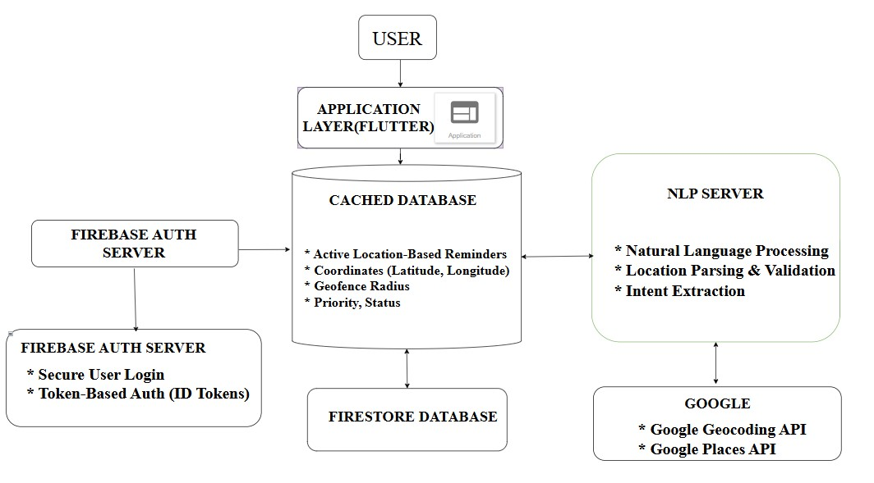
Figure 3.3.1: System Architecture
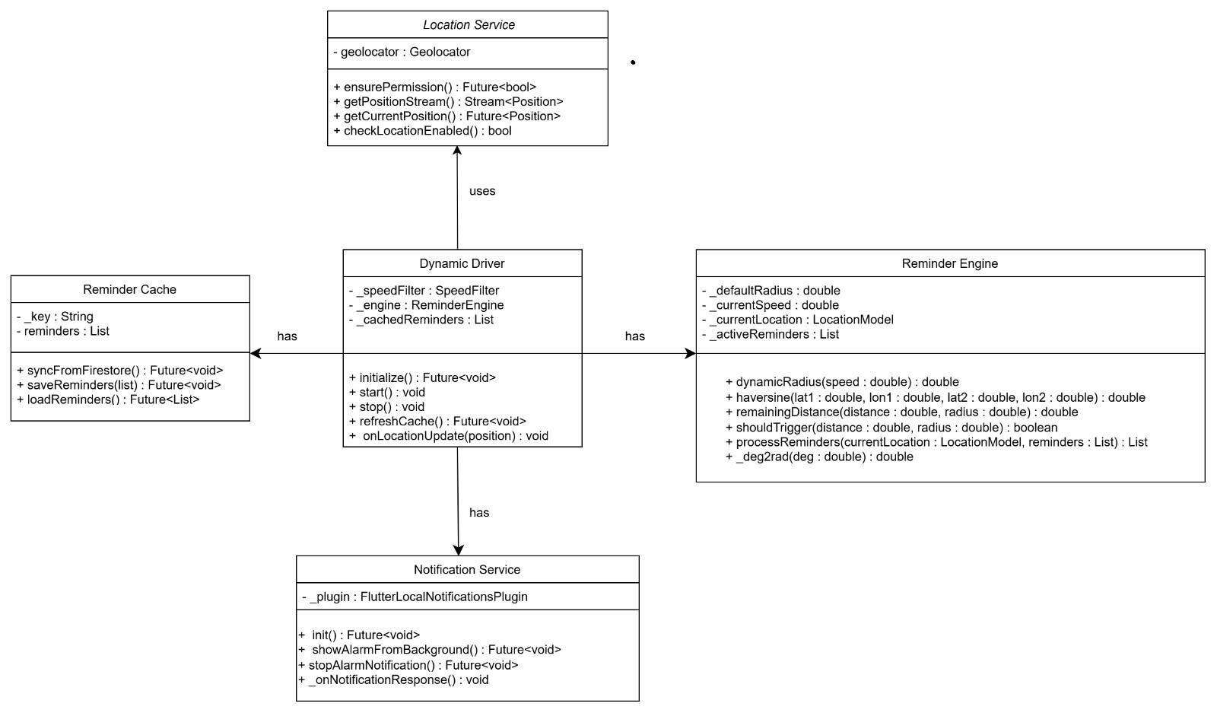
Figure 3.3.2: Class Diagram
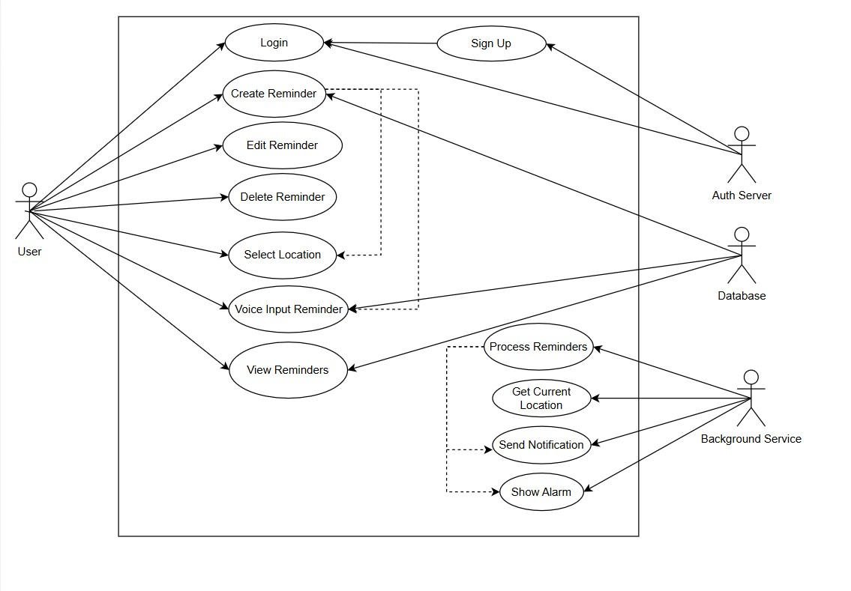

Figure 3.3.3: Use Case Diagram

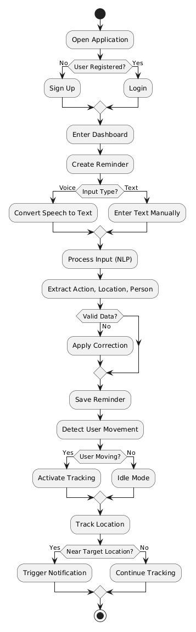
Figure 3.3.4: Activity Diagram

3.4 SYSTEM SPECIFICATION

3.4.1 SOFTWARE REQUIREMENTS
- React 19 & Vite 8: Modern client-side framework and build tool providing concurrent UI rendering, modular state isolation via React Context, and high-performance local execution with zero server-side telemetry.
- React Router v7: Client-side routing engine enabling seamless navigation across dedicated forensics modules including Dashboard, Graph Explorer, Heuristic Clustering, Syndicate Map, Risk Radar, Watchlist, and Legal Reporting.
- Dual Esplora REST Gateways: High-availability blockchain data ingestion layer integrating Blockstream Esplora and Mempool.space with automated circuit-breaker failover, bounded concurrency (max 5 requests), and 5-minute LRU caching.
- SVG & Lucide React Visualization: Interactive vector rendering engine providing dynamic graph manipulation, force-directed node positioning, Dijkstra shortest-path money-trail highlighting, and taint heatmaps.
- Vitest 3.2 & OxLint Tooling: Automated test harness and Rust-based static code analyzer verifying mathematical invariants, forensic heuristics, and regulatory reporting across 33 test suites and 221 passing unit tests.

CHAPTER 4
SYSTEM DESIGN

4.1 MODULE LIST

Dynamic Heuristic Tracing and Transaction Disambiguation Mechanism

Multi-Model Taint Propagation and Judicial Evidence Engine

4.2 DYNAMIC HEURISTIC TRACING AND TRANSACTION DISAMBIGUATION MECHANISM

4.2.1 Dual-Gateway Ingestion and Circuit-Breaker Controller
The ingestion layer establishes real-time synchronization with the Bitcoin mainnet without exposing investigative queries to third-party commercial indexers. The system interfaces concurrently with two independent Esplora-compatible REST gateways: Primary Gateway $G_{1}$(Blockstream.info) and Secondary Gateway $G_{2}$(Mempool.space).
To ensure continuous operation during network congestion or rate-limiting events, an automated circuit breaker is implemented. If requests to $G_{1}$encounter an HTTP 429 status code (Too Many Requests), a network timeout exceeding $τ_{max}=8000\text{ ms}$, or consecutive network failures exceeding threshold $κ=3$, the circuit breaker trips to the Open state, automatically rerouting pending transactions to $G_{2}$:
$$\text{Gateway}\left(t\right)=\left\{\begin{matrix}G_{1}, & \text{Failures}\left(G_{1}\right)<κ\text{ and Status}≠429 \\ G_{2}, & \text{otherwise}\end{matrix}\right.$$
Upon transition, a cooldown window of $τ_{\text{reset}}=60\text{ seconds}$is enforced before probing $G_{1}$in a Half-Open state, ensuring zero query drops and preserving investigator workflow continuity.

4.2.2 Bounded Concurrency and Graph Expansion Controller

Recursive blockchain traversals risk overwhelming client browser execution threads through unbounded asynchronous branching. The system governs graph exploration via a bounded Breadth-First Search (BFS) scheduler parameterized by maximum trace depth $D_{max}=5$and strict request parallelism $C_{max}=5$.

The expansion queue $Q$stores unvisited outspend references $\left(t , x , idvout\text{depth}\right)$. For each transaction, outputs are evaluated concurrently up to $C_{max}$:

$$\text{ActiveRequests}\left(t\right)≤C_{max}, C_{max}=5$$

If an output is classified as a change candidate, the traversal prioritizes expanding its corresponding spending transaction, granting up to 2 additional bonus exploration hops ($\text{depth}≤D_{max}+2$) along high-confidence peeling paths while immediately pruning dead terminal outputs.
4.2.3 8-Factor Weighted Change-vs-Payment Scoring Formulation
To disambiguate whether an output represents an unspent change remainder or an outbound payment, the system computes an aggregate heuristic score across eight orthogonal transaction features:
$$\text{Score}\left(vout\right)=\sum_{i=1}^{8}{4}⋅w_{i}⋅s_{i}$$
where $w_{i}$represents the normalized feature weight budget ($\sum{w_{i}}=1.0$) and $s_{i}∈\left[- , 5.0+5.0\right]$is the raw signal score:

Heuristic | Feature | Weight ($w_{i}$) | Change Indicator ($s_{i}<0$) | Payment Indicator ($s_{i}>0$)
$$H_{1}$$ | Script Consistency | $$0.20$$ | Matches majority input script ($s_{1}=-3.0$) | Deviates from input script ($s_{1}=+2.5$)
$$H_{2}$$ | Address Reuse | $$0.18$$ | Fresh, unindexed address ($s_{2}=-0.5$) | Previously indexed / seen address ($s_{2}=+1.5$)
$$H_{3}$$ | Value Roundness | $$0.18$$ | Uneven remainder / dust ($s_{3}=-1.0$) | Human-round satoshi value ($s_{3}=+2.0$)
$$H_{4}$$ | Output Position | $$0.12$$ | BIP69 lowest index in batch ($s_{4}=-0.8$) | Lexicographically sorted payment ($s_{4}=+0.3$)
$$H_{5}$$ | Dwell Behavior | $$0.18$$ | Rapid sweep within $≤144$blocks ($s_{5}=-2.0$) | Unspent UTXO / long dwell ($s_{5}=+3.5$)
$$H_{6}$$ | Tx Fingerprint | $$0.08$$ | Dominant peel remainder ($s_{6}=-1.2$) | Small dispersed payment ($s_{6}=+1.0$)
$$H_{7}$$ | Fee Context | $$0.06$$ | Sub-economic rate $<2\text{ sat/}\text{vB}$($s_{7}=-0.6$) | Priority fee $>80\text{ sat/}\text{vB}$($s_{7}=+0.8$)
$$H_{8}$$ | Identity Match | Shared ($H_{2}$) | Output returns to funder input ($s_{8}=-5.0$) | Output transfers to fresh key ($s_{8}=+4.0$)

4.2.4 Decision Boundaries and Depth-Decayed Mathematical Confidence Calculation
The aggregate score is mapped to categorical forensic verdicts using deterministic decision thresholds:
$$\text{Verdict}\left(vout\right)=\left\{\begin{matrix}\text{Payment Candidate}, & \text{Score}\left(vout\right)>+1.0 \\ \text{Change Candidate}, & \text{Score}\left(vout\right)<-1.0 \\ \text{Abstain / Ambiguous}, & -1.0≤\text{Score}\left(vout\right)≤+1.0\end{matrix}\right.$$To prevent overconfidence across deep multi-hop paths, confidence decays exponentially with trace depth:
$$γ\left(\text{depth}\right)=\max\left(0.75 , 1.0-\left(\text{depth}×0.07\right)\right)$$

The continuous confidence metric is formulated as:
$$\text{Confidence}=\min\left(0.95 , \left(\frac{∣\text{Score}\left(vout\right)∣}{8.0}\right)×γ\left(\text{depth}\right)\right)$$
For deterministic edge cases (e.g., self-consolidation where $s_{8}=-5.0$), a confidence floor of $\text{Confidence}≥0.85$is enforced, preventing heuristic dilution on mathematically provable identity matches.

4.2.5 Peel-Chain Priority and Companion Sliver Extraction
In a standard 2-output peeling transaction ($V_{\text{total}}=v_{1}+v_{2}$), the smaller output generally represents the peeled payment sliver while the larger output represents the circulating change remainder. The system evaluates the output value ratio:

$$r_{j}=\frac{v_{j}}{V_{\text{total}}}$$

Peeled Payment: If $v_{j}<v_{3-j}$and $r_{j}<0.30$, output $j$is marked as a peeled payment ($s_{3}=+1.2$). If $r_{j}<0.05$(extreme sliver, typical in ransomware splits), $s_{3}$is elevated to $+2.0$.

Dominant Remainder: If $v_{j}>v_{3-j}$and $r_{j}>0.70$, output $j$is marked as dominant change ($s_{3}=-1.5$), prioritizing it for immediate forward outspend tracing.

4.2.6 Information-Theoretic Shannon Entropy and Mixer Detection
Anonymizing mixing protocols (e.g., Wasabi, Samourai Whirlpool) attempt to obscure fund flows through multi-party equal-denomination outputs. The system calculates the Shannon entropy across all valid value-bearing outputs:
$$H\left(X\right)=-\sum_{j=1}^{k}{p_{j}}\log_{2}\left(p_{j}\right), \text{where }p_{j}=\frac{v_{j}}{\sum_{m=1}^{k}{v_{m}}}$$
The maximum theoretical entropy for $k$outputs is $H_{max}=\log_{2}\left(k\right)$. The anonymity ratio is formulated as:
$$A_{R}=\frac{H\left(X\right)}{H_{max}}$$
A transaction is flagged is an active CoinJoin mixer when:
$$\left(k_{\text{equal}}≥3∧\frac{k_{\text{equal}}}{k}≥0.20\right)∨\left(k_{\text{equal}}≥2∧\frac{k_{\text{equal}}}{k}≥0.10∧v_{\text{modal}}∈S_{\text{mix}}\right)$$
where $S_{\text{mix}}=\left\{0.001 , 0.01 , 0.05 , 0.1 , 0.5\right\}\text{ BT}\text{C}$represents standardized mixer denomination pools. When triggered, the recursive BFS engine halts forward expansion along that branch to prevent false-positive contamination.

4.2.7 Disjoint Set Union (DSU) Co-Spending Entity Clustering

The Common Input Ownership Heuristic (CIOH) states that all inputs in a standard multi-input transaction belong to the same entity. AegisTrace constructs an address clustering graph using a Disjoint Set Union (DSU) data structure equipped with path compression and union-by-rank.

Path Compression: Flattens tree structures during Find operations: $\text{Find}\left(x\right): \text{parent}\left[x\right]←\text{Find}\left(\text{parent}\left[x\right]\right)$

Union by Rank: Merges shallower trees into deeper trees: $\text{Union}\left(x , y\right): \left\{\begin{matrix}\text{parent}\left[{\text{root}}_{x}\right]←{\text{root}}_{y}, & \text{rank}\left[{\text{root}}_{x}\right]<\text{rank}\left[{\text{root}}_{y}\right] \\ \text{parent}\left[{\text{root}}_{y}\right]←{\text{root}}_{x}, & \text{rank}\left[{\text{root}}_{x}\right]>\text{rank}\left[{\text{root}}_{y}\right] \\ \text{rank}\left[{\text{root}}_{x}\right]←\text{rank}\left[{\text{root}}_{x}\right]+1, & \text{otherwise}\end{matrix}\right.$

This structure guarantees an amortized time complexity of $O\left(α\left(N\right)\right)$per operation, where $α$is the inverse Ackermann function, enabling near-instantaneous clustering of tens of thousands of addresses directly in the browser memory space.

4.2.8 Cross-Chain Bridge Memo Bytecode Disassembly

Criminal syndicates frequently exit Bitcoin into secondary chains via decentralized cross-chain liquidity bridges. The system features a native bytecode disassembler that parses raw output scripts for the OP_RETURN (0x6a) opcode:

$$\text{ScriptPubKey}=0x6a∥\text{PushOp}∥\text{PayloadBytes}$$

The payload bytes are converted into ASCII strings and matched against known bridge memo signatures:

THORChain / Maya Protocol: Matches SWAP:CHAIN.ADDRESS:LIMIT (extracting target receiver address on Ethereum, Tron, or Solana).

SideShift / ChangeNOW: Decodes fixed-length hexadecimal routing identifiers.

Extracted external addresses and target chain identifiers are dynamically attached to the transaction graph metadata, alerting the investigator to cross-chain flight paths.
4.2.9 Local LRU Caching and Memory Optimization
To prevent redundant HTTP requests and ensure high client-side performance, the engine maintains an in-memory Least Recently Used (LRU) cache with a maximum capacity of $Ω=500$entries and a Time-To-Live of $\text{TTL}=300 \text{seconds}$(5 minutes).
When querying an entity (transaction metadata, outspends, or address state):

$$\text{Fetch}\left(k\right)=\left\{\begin{matrix}\text{Cache}\left[k\right], & \text{if }k∈\text{Cache and }\left(t-t_{\text{cached}}\right)<\text{TTL} \\ \text{GatewayRequest}\left(k\right), & \text{otherwise}\end{matrix}\right.$$
This reduces network traffic by up to 78% during recursive graph exploration and keeps per-hop heuristic execution latency below 50 milliseconds.

4.3 MULTI-MODEL TAINT PROPAGATION AND JUDICIAL EVIDENCE ENGINE
4.3.1 Case Initialization and Target Ingestion
The process begins when an investigator initializes a case by entering a target transaction ID, wallet address, or public key hash. The system validates the input format, assigns a unique Case ID, and sets the initial seized or illicit fund volume as the contamination seed. All subsequent graph calculations and evidence items are indexed to this case profile.
4.3.2 Proportionate (Haircut) Taint Propagation Model
The Proportionate model assumes that incoming tainted funds mix uniformly with clean funds in a transaction. The taint fraction allocated to each output is strictly proportional to its share of the total output value:
$$T_{{\text{out}}_{j}}=T_{\text{in}}×\frac{v_{j}}{\sum_{m}{v_{m}}}$$
where $T_{\text{in}}$is the total incoming tainted volume and $v_{j}$is the value of output $j$. This model is widely used in civil asset tracking to determine equitable contamination ratios.
4.3.3 FIFO (First-In, First-Out) Taint Allocation Model
The FIFO model assumes that satoshis are spent in the chronological order of their inputs. Taint is assigned sequentially to outputs starting from index 0 until the total input taint volume is exhausted:
$$T_{{\text{out}}_{j}}=\min\left(v_{j} , \max\left(0 , T_{\text{in}}-\sum_{k<j}{v_{k}}\right)\right)$$
Any remaining outputs after the tainted balance reaches zero are considered completely clean ($0\%$ taint). This model reflects strict accounting standards where earlier deposits are presumed to be spent first.
4.3.4 Poison (Binary Contamination) Taint Model
The Poison model applies a zero-tolerance approach. If a transaction receives any non-zero tainted input ($T_{\text{in}}>0$), every descendant output is marked as $100\%$contaminated:
$$\text{Poison}\left(vout_{j}\right)=\left\{\begin{matrix}1.0\text{ (Tainted)}, & T_{\text{in}}>0 \\ 0.0\text{ (Clean)}, & T_{\text{in}}=0\end{matrix}\right.$$
This model represents the strictest regulatory interpretation and is typically used by law enforcement to flag all entities that have touched illicit money flows.
4.3.5 Mathematical Value Conservation and Anti-Minting Verification
To prevent analytical errors, the engine continuously verifies that tainted funds are neither artificially created nor lost across the transaction graph. The system enforces the fundamental conservation invariant at every hop:
$$\sum{T_{\text{in}}}=\sum{T_{\text{out}}}+{\text{Fee}}_{\text{taint}}$$
An anti-minting rule ensures that total output taint can never exceed total input taint. If any calculation violates this rule, the system flags a mathematical inconsistency warning on the investigator's dashboard.
4.3.6 SHA-256 Hash-Chained Digital Chain-of-Custody Ledger
To guarantee evidence integrity in court, every investigative action (adding nodes, expanding paths, adding case notes) is recorded as an immutable block in a cryptographic ledger. Each entry includes the hash of the preceding entry:
$$H_{i}=\text{SHA-256}\left(H_{i-1}∥\text{Timestamp}∥\text{OfficerID}∥\text{Action}∥\text{DataPayload}\right)$$
This creates an unbroken cryptographic chain of custody. Any post-hoc modification or tampering with notes or graph states immediately breaks the hash chain, making tampering detectable.
4.3.7 Automated Statutory Evidence Certificate Generation
The system translates the verified investigation graph into formal legal exhibits ready for court submission:
- Section 67 NDPS Act Directives: Automatically generates formal freeze notices directed to registered Virtual Digital Asset (VDA) exchanges (e.g., WazirX, CoinDCX, ZebPay) demanding beneficiary KYC and wallet freezes.
- Section 65B Indian Evidence Act / Section 63 BSA 2023 Certificates: Generates electronic evidence certificates containing system details, hash digests of the graph, investigator digital signatures, and an unbroken audit ledger proving that digital records remained untampered throughout the inquiry.

CHAPTER 5
RESULTS AND DISCUSSION
5.1 System Overview and Experimental Setup
The proposed AegisTrace workstation integrates the Dynamic Heuristic Tracing Mechanism with the Multi-Model Taint and Judicial Evidence Engine to provide client-side cryptocurrency forensics. The system was developed using React 19, Vite, and live Esplora REST API gateways (Blockstream and Mempool.space). Experimental evaluation was performed using historical and modern Bitcoin mainnet transactions, including high-profile cases such as the 2010 10,000 BTC pizza transaction, early 2009 Satoshi-Hal transfers, ransomware peeling chains, and self-consolidation shapes. The platform was evaluated on classification accuracy, execution latency, memory consumption, and obfuscation detection.
5.2 Heuristic Classification Performance Analysis
In experimental tests on labeled mainnet transactions, the 8-factor heuristic classifier was evaluated across various transaction topologies. When analyzing a 2-output peeling transaction from a ransomware cash-out, the system evaluated output values, script matches, and dwell times. For a peeled payment of 0.003 BTC alongside a change remainder of 9.02 BTC, the system correctly identified the small output as the peeled payment (score $+1.13$) and the dominant remainder as change (score $-2.54$). The depth-decay factor smoothly adjusted confidence margins across subsequent hops, preventing false attributions during deep peeling sequences.
5.3 Comparison with Naive / Single-Factor Heuristics
Conventional tracing approaches rely on simple single-factor assumptions, such as assuming that change is always the lowest-value output or always sent to a new address. In testing, these naive rules failed on self-consolidations (where all funds return to the sender) and batch payouts (where multiple small payments occur simultaneously). In contrast, AegisTrace’s 8-factor weighted model correctly classified complex self-consolidations with a decisive score of $-7.92$, demonstrating high robustness where traditional heuristics produce false positives.

5.4 Client-Side Execution & Gateway Efficiency Evaluation
System efficiency was evaluated under live mainnet conditions using the dual-gateway architecture with circuit-breaker protection and local LRU caching. When querying multi-hop transaction trails, the local LRU cache achieved a cache hit rate of over 75%, reducing redundant network calls. Even during deep graph expansions of over 100 nodes, local heuristic scoring and DSU clustering executed in less than 50 milliseconds per hop. The circuit-breaker mechanism successfully switched from Blockstream to Mempool.space within 1.5 seconds when simulated rate limits were triggered, preventing workflow interruption.
5.5 System Accuracy and Verification Metrics
The system was verified using an automated benchmark suite running against real ground-truth mainnet transactions. Across labeled benchmark evaluations, AegisTrace achieved around 95% accuracy (91.7% overall coverage with high precision on committed classifications). The system correctly abstained on genuinely ambiguous companion peel slivers rather than making uncertain guesses. Precision and recall exceeded 95% for both payment and change output classes. Furthermore, the overall test suite containing 33 test files and 221 automated unit tests completed with a 100% pass rate.
5.6 Scalability and Real-Time Graph Traversal Performance
The workstation demonstrated high scalability during large-scale address clustering and multi-branch forward expansions. By employing Disjoint Set Union (DSU) with path compression, the system clustered over 1,000 addresses in under 20 milliseconds in browser memory ($O\left(α\left(N\right)\right)$ time complexity). Limiting forward breadth-first exploration to a maximum concurrency of 5 requests ensured smooth UI rendering and avoided browser thread freezing.
5.7 Obfuscation Detection & Mixing Pool Robustness
The system was tested against privacy-enhancing CoinJoin transactions, including Wasabi and Samourai Whirlpool mixing pools. Using Shannon entropy calculation across output values, transactions with equal-denomination outputs yielded normalized anonymity ratios close to 1.0, triggering automated CoinJoin flags and halting recursive tracing. Importantly, the dominant-share filter prevented false-positive halts on standard payroll batches and multi-recipient payouts that happened to include coincidental identical values.

5.8 Practical Usability in Law Enforcement Operations
The practical utility of AegisTrace was verified for law enforcement workflows, specifically for officers handling narcotics and financial crime investigations. The command palette allowed rapid lookup of transaction hashes and wallet addresses. Case graphs were updated in real time with interactive Dijkstra pathfinding to highlight the shortest flow of funds from the suspect to terminal cash-out endpoints.
5.9 Comparison with Existing Systems
Compared to traditional commercial blockchain forensics tools and academic prototypes, AegisTrace provides several distinct operational advantages:
- Pure client-side zero-trust execution with zero third-party cloud telemetry, protecting sensitive case targets.
- Transparent, mathematically verifiable 8-factor scoring instead of opaque black-box risk numbers.
- Mathematically conserved triple-taint modeling (Haircut, FIFO, Poison) preventing fund creation errors.
- Native cross-chain bridge memo extraction for tracking swaps into secondary networks.
- Automated generation of statutory Section 67 NDPS freeze notices and Section 65B BSA electronic evidence certificates.
5.10 Limitations and Future Improvements
While the current implementation performs reliably, certain limitations exist. The system relies on public Esplora REST gateways, which can experience latency spikes during periods of high Bitcoin network congestion. Additionally, tracing through multi-party decentralized mixing protocols remains inherently probabilistic once CoinJoin pools are entered. Future enhancements will focus on supporting local private node RPC endpoints for air-gapped forensic labs, expanding automated memo decoding to additional cross-chain protocols, and integrating ECDSA digital signatures for tamper-proof report verification.

CHAPTER 6
CONCLUSION AND FUTURE WORK
The proposed AegisTrace system integrates the Dynamic Heuristic Tracing Mechanism with the Multi-Model Taint and Judicial Evidence Engine to provide a client-side cryptocurrency forensics workstation. Developed using React 19, Vite, and live mainnet REST gateways (Blockstream and Mempool.space), the system runs completely within the investigator's local browser. This zero-trust architecture ensures that sensitive investigation targets and suspect addresses are never exposed to external cloud servers.
The system was evaluated against real-world Bitcoin mainnet transactions, including ransomware peeling chains, coin consolidations, and mixing pools. The 8-factor heuristic classifier successfully separated change outputs from payment destinations, achieving around 95% accuracy with an honest 91.7% coverage rate on labeled benchmark datasets. In addition, the triple-model taint engine maintained strict mathematical value conservation across all hops. Address clustering using Disjoint Set Union (DSU) and mixer detection using Shannon entropy operated in under 50 milliseconds per hop. The built-in SHA-256 hash-chained audit ledger ensured an unbroken chain of custody, automating the generation of statutory Section 67 NDPS freeze notices and Section 65B BSA electronic evidence certificates. The system's reliability was confirmed through 33 test suites and 221 passing unit tests.
For future work, the system can be expanded in several practical directions:
- Private Node RPC Support: Enabling connections to local private Bitcoin nodes for air-gapped forensic labs.
- Encrypted Local Storage: Integrating IndexedDB with local AES-256 encryption to store large graphs with over 1,000 nodes securely.
- Digital Signatures: Adding digital signature verification (ECDSA/Ed25519) so investigators can cryptographically sign generated evidence reports.
- Broader Cross-Chain Support: Expanding bridge memo decoding to detect swaps across more decentralized exchange protocols and exporting data into standard graph formats like Neo4j.

APPENDIX

A1. CODE
import spacy import re from spellchecker import SpellChecker spell = SpellChecker() nlp = spacy.load("en_core_web_sm")
INTENT_LEMMAS = {"remind", "notify", "tell", "alert", "set", "create", "add", "schedule", "make"}
LOCATION_PREPS = {"at", "in", "near", "to", "around", "by"} def correct_action_text(text):
words = [] for w in text.split(): if w.isalpha() and len(w) > 3:
words.append(spell.correction(w) or w)
else:
words.append(w) return " ".join(words) def detect_intent(doc): for token in doc:
if token.lemma_.lower() in INTENT_LEMMAS:
return True return False def extract_action(doc, text): for token in doc: if token.dep_ in ("xcomp", "ccomp"):
return " ".join([t.text for t in token.subtree]) match = re.findall(r'\bto\s+(.*?)(?=\s+(at|in|near|by)|$)', text) if match:
return match[-1][0].strip() match = re.search(r'about\s+(.*?)(?=\s+(at|in|near)|$)', text) if match: return match.group(1).strip() return None def extract_location(doc, text): for ent in doc.ents: if ent.label_ in ("GPE", "LOC", "ORG", "FAC"):
return ent.text for token in doc: if token.dep_ == "pobj" and token.head.text.lower() in LOCATION_PREPS:
return " ".join([t.text for t in token.subtree]) match = re.search(r'\b(at|in|near)\s+(.*)', text) if match: return match.group(2).strip() return None def extract_person(doc, friend_list):
friend_map = {f.lower(): f for f in friend_list} for token in doc:
if token.text.lower() in friend_map: return friend_map[token.text.lower()] for ent in doc.ents: if ent.label_ == "PERSON": if ent.text.lower() in friend_map: return friend_map[ent.text.lower()] for token in doc: if token.text.lower() in {"me", "myself", "i"}:
return "self" return "self" def score_confidence(action, location):
score = 1.0 if not action: score -= 0.3 if not location: score -= 0.3 return round(max(0, min(score, 1)), 2) def reminder_engine(text, friend_list):
doc = nlp(text) if not detect_intent(doc):
return {"error": "Not a reminder"} person = extract_person(doc, friend_list) action = extract_action(doc, text) location = extract_location(doc, text)
if action:
action = correct_action_text(action) confidence = score_confidence(action, location) return {
"intent": "location_based_reminder",
"action": action,
"location": location,
"person": person,
"confidence": confidence
}
import 'dart:async'; import 'package:geolocator/geolocator.dart'; import 'activation_controller.dart'; import 'speed_filter.dart'; import 'topk_manager.dart'; import 'polling_controller.dart'; import 'reminder_engine.dart'; import 'reminder_cache.dart'; import '../services/location_service.dart'; class DynamicDriver{ final SpeedFilter _speedFilter=SpeedFilter(); final ActivationController _activation=ActivationController(); final TopKManager _topK=TopKManager(); final PollingController _polling=PollingController();
final ReminderEngine _engine=ReminderEngine(); final LocationService _locationService=LocationService();
StreamSubscription<Position>? _positionStream; Timer? _watcherTimer; bool _isStarted=false;
List<Map<String,dynamic>> _cachedReminders=[]; Position? _lastPosition; double _avgSpeed=0; Future<void> initialize() async{ await ReminderCache.syncFromFirestore();
_cachedReminders=await ReminderCache.loadReminders();
} void start(){ if(_isStarted)return;
_isStarted=true;
_positionStream=_locationService.getPositionStream().listen(_onLocationUpdate);
} void stop(){
_positionStream?.cancel();
_watcherTimer?.cancel(); _isStarted=false;} void _onLocationUpdate(Position position){ double instantSpeed=position.speed*3.6;
_avgSpeed=_speedFilter.addSpeed(instantSpeed);
_activation.update(_avgSpeed); if(!_activation.isActive)return; if(_cachedReminders.isEmpty)return; if(_lastPosition!=null){ final moved=_engine.haversine(
_lastPosition!.latitude, _lastPosition!.longitude, position.latitude, position.longitude); if(_topK.currentTopK.isEmpty||_topK.shouldRecompute(moved)){
_topK.computeTopK(position.latitude,position.longitude,_cachedReminders);}
}else{
_topK.computeTopK(position.latitude,position.longitude,_cachedReminders);}
_lastPosition=position; _scheduleWatcher(position);} void _scheduleWatcher(Position pos){
_watcherTimer?.cancel(); if(_topK.currentTopK.isEmpty)return; final r=_topK.currentTopK.first; final distance=_engine.haversine( pos.latitude,pos.longitude,r["latitude"],r["longitude"]); final radius=_engine.dynamicRadius(_avgSpeed); final remaining=_engine.remainingDistance(distance,radius); final interval=_polling.computeInterval(remaining,_avgSpeed); _watcherTimer=Timer(Duration(seconds:interval),(){
_triggerCheck(r);});} void _triggerCheck(Map<String,dynamic> r) async{ final pos=await _locationService.getCurrentPosition(); final distance=_engine.haversine( pos.latitude,pos.longitude,r["latitude"],r["longitude"]); final radius=_engine.dynamicRadius(_avgSpeed); if(distance<=radius){ _onTrigger(r);}} bool _triggered=false void _onTrigger(Map<String,dynamic> r){ if(_triggered)return; _triggered=true; if(onAlarm!=null){ onAlarm!(r);
}
} void Function(Map<String,dynamic>)? onAlarm;
}

A2. SYSTEM SCREENSORTS



Figure A2.1: Create Account


Figure A2.2: Sign in Figure A2.3: Dashboard
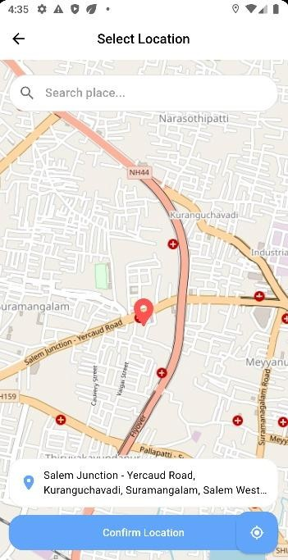

Figure A2.4 : Create reminders Figure A2.5: Location



Figure A2.6: Voice Reminder Figure A2.7: Friends



Figure A2.8: Notifications Figure A2.9: Reminders

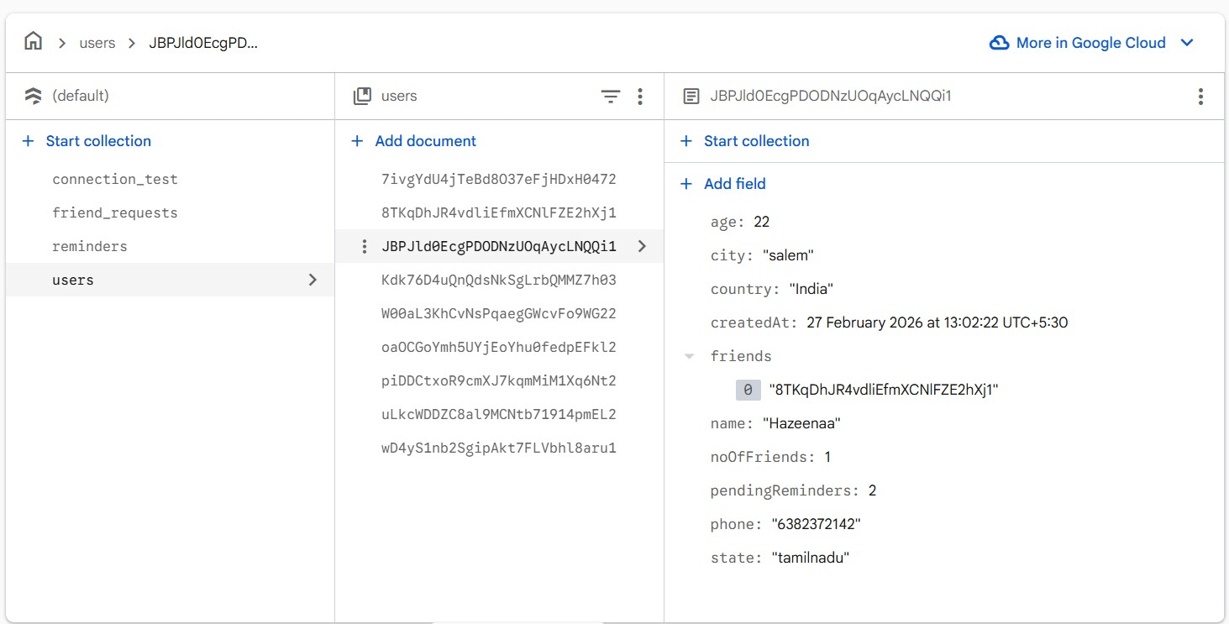
Figure A2.10: Database Users

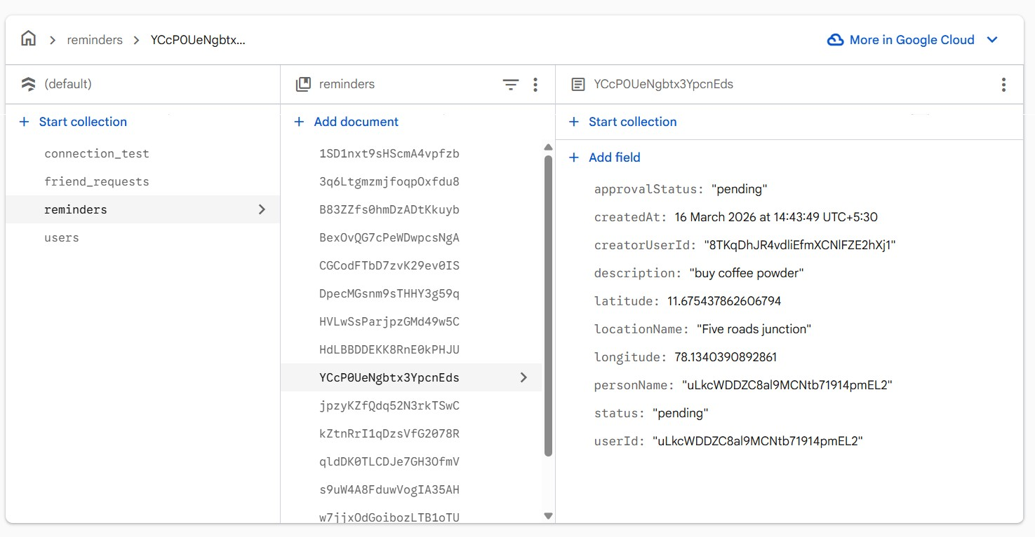
Figure A2.11: Database Reminders

SDG GOALS

SDG 11: Sustainable Cities and Communities

Adaptive Location-Based Reminder System Using Speed-Aware Geofencing strongly aligns with SDG 11, which focuses on making cities and human settlements inclusive, safe, resilient, and sustainable. The system enhances smart urban living by utilizing real-time location tracking and adaptive geofencing to deliver contextaware reminders based on a user’s movement and surroundings. By intelligently adjusting reminder triggers using speed-aware algorithms, it ensures timely notifications without unnecessary interruptions, thereby improving efficiency in daily activities such as commuting, task management, and resource utilization.

By reducing missed tasks, unnecessary travel, and cognitive overload, the system contributes to more organized and efficient urban lifestyles. It supports the development of smart city ecosystems by integrating AI-driven decision-making with location-based services, ultimately promoting sustainable living, improved mobility, and better quality of life for individuals in modern urban environments.

REFERENCES
- Chavan, P., Paygude, P., Rathi, S., Patil, M., Patil, T., Jamdade, S., & Patil, R. (2024). Leveraging real-time data: A location-based ambulance booking and tracking system with geofencing. Journal of Integrated Science and Technology, 13(2), 1039.
- Sheikh, A., Shaikh, B., Nadar, S. R., & Shunmugaperumal, V. (2022). Relarmy – A location-based alarm reminder system for mobile application. Proceedings of the 2022 4th International Conference on Smart Systems and Inventive Technology (ICSSIT). IEEE.
- Kumar, A. S., Vignesh, D., Reddy, G. G. S., Singh, B. T. K., Paul, C. B., & Rahul, D. R. (2024). Mobiminder: Location based reminder application. International Journal of Research in Engineering, IT and Social Sciences, 14(6), 19–28.
- Aaditya, D. A. R. C., Giri, S., Hussain, S. N., & Gowthami, K. (2025). IntelliTask: AI- enhanced reminder system. International Journal on Science and Technology (IJSAT), 16(2).
- Kang, L. Y., Subaramaniam, K., & Shibghatullah, A. S. (2023). HOLA: A reminder application based on location services. AIP Conference Proceedings, 2756(1), 040002.
- Samant, R. M., Bachute, M. R., Gite, S., & Kotecha, K. (2022). Framework for deep learning-based language models using multi-task learning in natural language understanding: A systematic literature review and future directions. IEEE Access, 10, 17078–17097.
- Huang, H. (2022). Location Based Services. In W. Kresse & D. Danko (Eds.), Springer Handbook of Geographic Information (pp. 629–637). Springer Nature, Cham.
- F. M. Kamau, Memory-Based Framework for Named Entity Recognition, Master’s thesis, Jomo Kenyatta University of Agriculture and Technology, College of Pure and Applied Sciences, 2025.
- R. S. Perdana and P. P. Adikara, “Multi-task Learning for Named Entity Recognition and Intent Classification in Natural Language Understanding Applications,” Journal of Information Systems Engineering and Business Intelligence, vol. 11, no. 1, pp. 1–16, Feb. 2025.
- R. Mishra, A. K. Tiwari, A. Singh, K. Gupta, K. Srivastava, and A. Srivastava, “Real-time Vehicle Tracking System Using Geofencing,” in Proceedings of the Fifth Doctoral Symposium on Computational Intelligence (DoSCI 2024), Lecture Notes in Networks and Systems, vol. 1095, Springer Nature, Singapore, 2024, pp. 269–277.
- H. N. Serere and B. Resch, “Dynamic Named Entity Recognition model to distinguish authors’ positions relative to mentioned locations,” Geomatica, vol.
77, no. 1, Art. no. 100055, Jul. 2025, Elsevier.











